**Ex4 - k-Nearest Neighbor algorithm**

**GitHub Link:**

[GitHub Link](https://github.com/Ojus999/Machine-Learning-Sem-6/tree/main)

**Colab Links:**

[Link](https://colab.research.google.com/drive/1hAOsX5a4kraAL_r9A4UMHUBFo3ynYWHP?usp=sharing)

**Aim:**

Develop a python program to predict the Online Shoppers Purchasing Intention using K-Nearest Neighbour algorithm

**Import Dependencies**

import pandas as pd

import numpy as np

import matplotlib.pyplot as plt

import seaborn as sns

from numpy import set_printoptions

from sklearn.feature_selection import RFE

from sklearn.linear_model import LogisticRegression

from sklearn import preprocessing

from sklearn.preprocessing import StandardScaler

from sklearn.model_selection import train_test_split

from sklearn.metrics import accuracy_score, roc_auc_score, roc_curve, confusion_matrix,f1_score, precision_score, recall_score

from imblearn.over_sampling import SMOTE

from imblearn.under_sampling import RandomUnderSampler

**Read Data**

df = pd.read_csv("online_shoppers_intention.csv")

**Preprocessing:**

df.head()

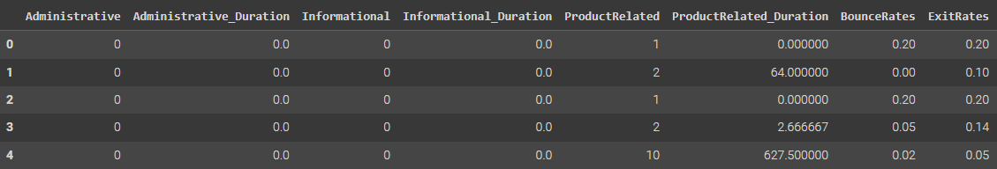

**Null Values**

df.info()

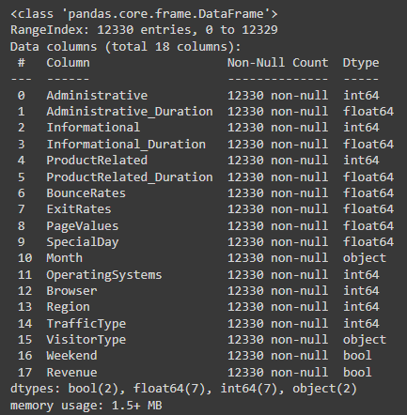

df.isnull().sum()

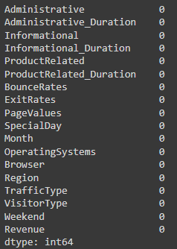

**Encoding**

label_encoder = preprocessing.LabelEncoder()

df['Month'] = label_encoder.fit_transform(df['Month']);

df['VisitorType'] = label_encoder.fit_transform(df['VisitorType'])

df['Weekend'] = label_encoder.fit_transform(df['Weekend'])

df['Revenue'] = label_encoder.fit_transform(df['Revenue'])

**Exploratory Data Analysis**

**Common Statistics**

df.describe().transpose()

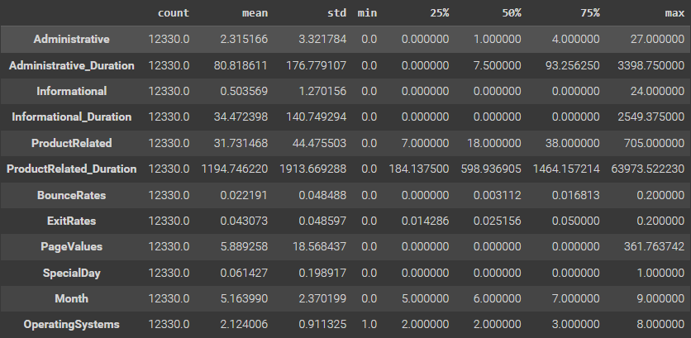

**Histograms**

sns.histplot(data = df, x = 'ProductRelated', bins = 10)

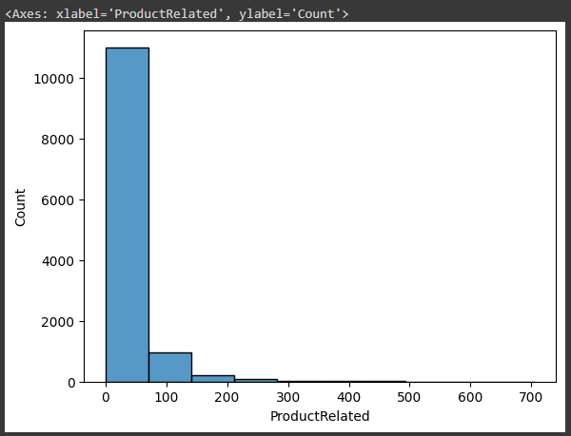

**Count Plot**

sns.countplot(data = df, x = 'Month')

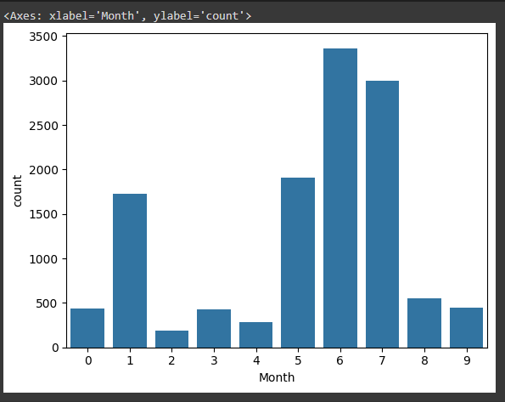

sns.countplot(data = df, x = 'Revenue')

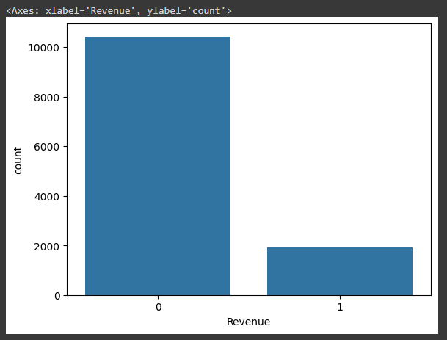

**Correlation**

df.corr()

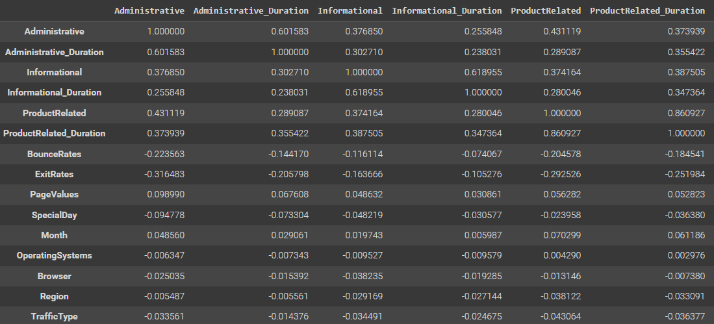

**Heatmap**

sns.heatmap(data = df)

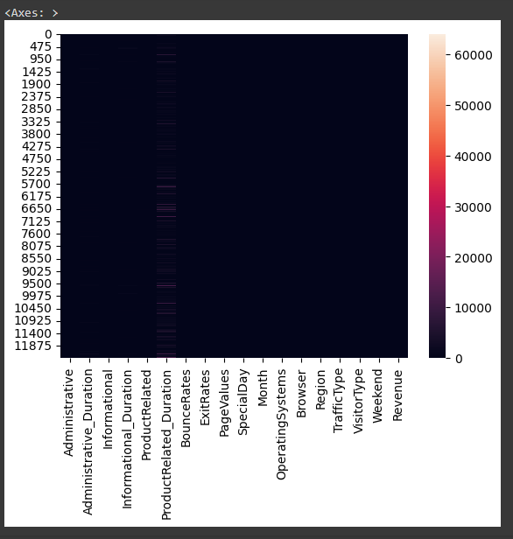

**Box Plot**

sns.boxplot(data = df, x = 'VisitorType', y = 'BounceRates')

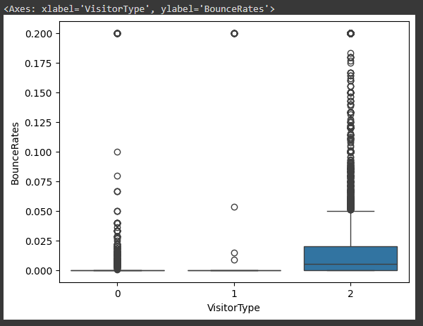

**Feature Engineering**

X = df.iloc[:,:17]

X

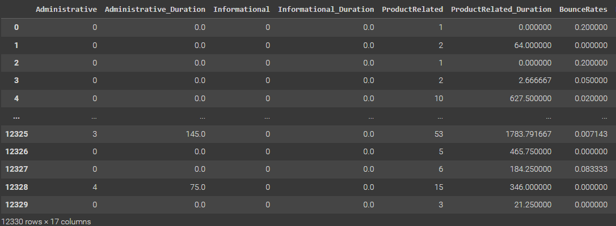

y = df.iloc[:,-1:]

y

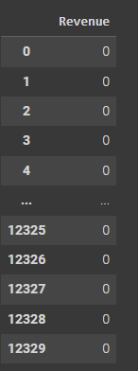

**Split Data**

smote = SMOTE()

rus = RandomUnderSampler(random_state=42, sampling_strategy = 'majority')

X_train, X_test, y_train, y_test = train_test_split(X, y, random_state = 42, test_size = 0.2)

**Sampling**

print((y.value_counts()))

X_resampled, y_resampled = smote.fit_resample(X_train, y_train)

print((y_resampled.value_counts()))

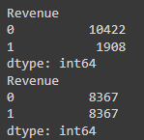

**Model Building**

**Normalization**

# data normalization with sklearn

from sklearn.preprocessing import MinMaxScaler

# fit scaler on training data

norm = MinMaxScaler().fit(X_train)

# transform training data

X_train_norm = norm.transform(X_train)

# transform testing dataabs

X_test_norm = norm.transform(X_test)

# fit scaler on training data

norm = MinMaxScaler().fit(X_train)

**Fit Model**

from sklearn.neighbors import KNeighborsClassifier

model = KNeighborsClassifier(n_neighbors=11)

model2 = KNeighborsClassifier(n_neighbors=11)

model.fit(X_train, y_train)

model2.fit(X_resampled, y_resampled)

y_pred = model.predict(X_test)

y_pred2 = model2.predict(X_test)

**Plotting Metrics**

import matplotlib.pyplot as plt

y_pred_proba = model.predict_proba(X_test)[::,1]

auc = roc_auc_score(y_test, y_pred_proba)

fpr, tpr, _ = roc_curve(y_test,  y_pred_proba)

plt.plot(fpr,tpr,label="with oversampling, auc="+str(auc), )

x = [0, 1]

y = [0, 1]

y_pred_proba2 = model2.predict_proba(X_test)[::,1]

auc2 = roc_auc_score(y_test, y_pred_proba2)

fpr, tpr, _ = roc_curve(y_test,  y_pred_proba2)

plt.plot(fpr,tpr,label="without oversampling, auc="+str(auc2), color='red')

print("Accuracy score without oversampling:",accuracy_score(y_test, y_pred))

print("F1 score without oversampling:",f1_score(y_test, y_pred))

print("Precision without oversampling:",precision_score(y_test, y_pred))

print("Recall without oversampling:",recall_score(y_test, y_pred))

print()

print("Accuracy score with oversampling:",accuracy_score(y_test, y_pred2))

print("F1 score with oversampling:",f1_score(y_test, y_pred2))

print("Precision with oversampling:",precision_score(y_test, y_pred2))

print("Recall with oversampling:",recall_score(y_test, y_pred2))

plt.plot(x,y)

plt.legend(loc=4)

plt.show()

